Schneider, Bill. Best Easy Day Hikes : Canyonlands & Arches. Falcon Publishing, Inc, 1997.
Devils Garden
Type of hike: Out and back or loop.
Total distance: 2 miles to Landscape Arch, 4 miles to Double O Arch, or 7.2 miles to Double O Arch returning by the primitive loop trail, including all spur trails to points of interest.
Elevation gain: Minimal. Time required: 1-4 hours depending on length of hike.
Maps: Trails Illustrated Arches National Park and USGS Arches National Park.
Starting point: Devils Garden Trailhead Parking Area.
Finding the trailhead: To find the trailhead, drive north into the park on the main road for 19 miles and park in the large parking area at the Devils Garden Trailhead. The trailhead is at the end of the road where it makes a small loop. Be sure to stay on the loop instead of turning into the Devils Garden Campground.
Key points: 0.25 Spur trail to Tunnel and Pine Tree arches. 0.8 Landscape Arch. 1.0 Wall Arch. 1.4 Navajo Arch. 1.5 Partition Arch. 2.0 Double O Arch. 2.1 Junction with Primitive Loop Trail. 2.5 Dark Angel. 2.9 Private Arch. 6.2 Junction with main trail. 7.2 Devils Garden Trailhead.
The hike: If you take the primitive loop and all of the short spur trails to nearby arches and other features, this becomes the longest hike on maintained trails in Arches National Park. It's also one of the most spectacular hikes you can take in any national park. However, taking the entire loop would probably not qualify as an easy hike, so you can make it an easy hike by merely turning back after seeing Landscape Arch and, perhaps, taking the short side trip to Pine Tree Arch
You can hike the entire loop in about 2 hours, but you could — and probably should — spend an entire day checking out the area and relaxing along the way. In any case, be sure to carry extra water. Also, you might want to get up early to take this hike to beat the heat — and to be sure you find a parking spot in the large but heavily used parking area. About 0.25 mile from the trailhead, the trail splits. To go to landscape Arch and Double O Arch and to complete the loop, take the left hand fork. The right hand fork takes you on a short spur trail down to Pine Tree and Tunnel arches. If you take this spur trail, it splits again at the bottom of a small hill. Go left to Pine Tree Arch and right to Tunnel Devils Garden
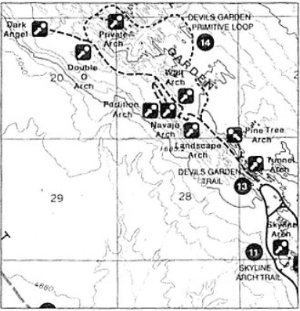

© National Geographic/Trails Illustrated

