http://www.zionnational-park.com/peek-a-boo.htm

 |  |  | 
 | Zion National Park Lodging Park Info Vacation Weather Photos Hike SR-9 Slots Backpack Camping
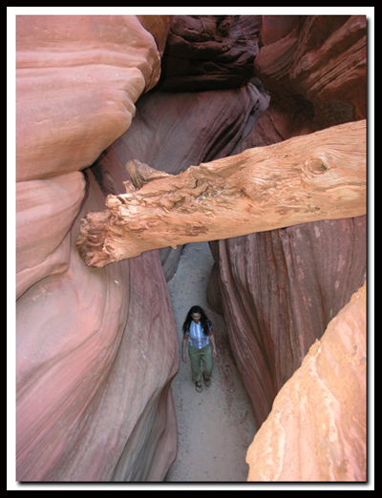

Red Canyon or as it's called by the locals: Peek-a-Boo
Southern Utah has it’s share of unique desertscapes, but the land here offers something different too - slot canyons. Abundant, yet hidden gems, that start out as small cracks in the earth that, overtime water has forced to become deep and narrow sandstone slots. The beauty of these dimly lit chasms entice hikers to explore into their depths. The price of admission into such a canyon often requires long hikes, down-climbing and rappelling skills, as well as an involved knowledge of rope work. Fortunately, there are some slot canyons that can be experienced without such a hefty price. Red Canyon, or as locals call it: Peek-a-boo, does not require any hiking to get to, but instead is an adventure that has the thrill of 4-wheeling on deep sand through a desert landscape of junipers, pinions, yuccas and cacti. The trip culminates with an easy stroll through a slender passage that will tantalize photographer and hiker alike with a visual array of warm reds, cool browns and hot oranges windswept into rippled and fluted sandstone walls. This is not the Peek-a-Boo slot canyon found in the Escalante area.
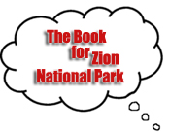
Peek-a-boo at a Glance
Photo Album: Pictures
Maps: Driving Map
Day Hike: Yes
Hiking: .7 miles round-trip.
Average Hiking Time: 1 hour exploring and 3 hours driving.
Difficulty: Easy hiking.
Equipment: 4WD
Sun Exposure: Full Sun
Trail Usage: Low
Trailhead: Best Friends Animal Sanctuary (Angel Canyon) located between Kanab and Mt. Carmel Jct.
Trailend: Same as trailhead
Best Season: Year-round, when weather cooperates. Hiking in slot canyons presents a very real danger from flash flooding. Do not hike this trail if it is raining. Remember a storm far off can trigger a flash flood.
Elevation: 5525 feet
Off the Beaten Path: Yes
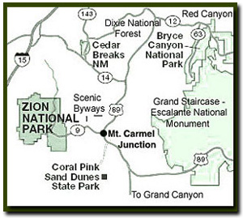 Prepare for driving in Deep Sand
Begin by loading your 4WD vehicle with refreshments and gasoline. Be sure to have an air compressor, so that if the need arises you can refill tires after releasing air pressure in order to "float" over the deep sandy road. Bring a trash bag to haul out any trash you might have accumulated.
As of 2010 there are now 2 trailheads. An ATV club has provided a new one but in our travels it's not the best of the two unless you are a hardcore four wheel driver. If you are looking on a map you will see the slot canyon marked as Red Canyon, but the locals have chose to call it Peek-a-Boo Slot Canyon, perhaps because of the nearby section of Dixie National Forest known as Red Canyon. This is also a 4WD area as well as the very nearby Coral Pink Sand Dunes. ATV enthusiasts will love this area between Kanab, Utah and Mt. Carmel Jct. Utah.

Directions to Zion National Park  From the North: Travel I-15 south, past Beaver. exit on Hwy 20. Follow US-89 to Mount Carmel Junction. Take SR-9 to Zion's east entrance.  From Arizona: Travel US-89A through Fredonia, Arizona and Kanab Utah. Follow US-89 to Mount Carmel Junction. Take SR-9 to the east park entrance.  From the South: Travel I-15 north. Take exit 16 and travel through Hurricane to LaVerkin. Continue on SR-9 to the south entrance of the park. SR-9 through Zion National Park is always open and is also called the Zion-Mt. Carmel Highway. See restrictions for RV's.  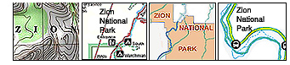 |  |  | 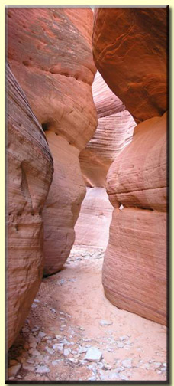
  Red Canyon or Peek-a-boo Slot Canyon as locals call it.
 | Lodging and services are available on the gorgeous east side of Zion National Park, where guests are close to Zion National Park (12 miles), Bryce Canyon National Park (60 miles), Cedar Breaks National Monument (45 miles), Coral Pink Sand Dunes (12 miles), and the North Rim of the Grand Canyon (85 miles). It's where city traffic is absent and the skies are bright and clean.
Option 1 - ATV Club Trailhead - Look for the sign located 8.5 miles from the Chevron in Mount Carmel Junction and 7.5 from the Kanab City limit sign. Follow BLM Road 102 to the slot canyon.
Option 2 - Original Trailhead - From the Chevron in Mount Carmel Junction, drive 9.2 miles south on US-89, toward Kanab. Look on the left side of the road for mile-post 72 and the turn-off to the Coral Pink Sand Dunes on the right side. Just past these landmarks make a left turn onto the next road, which will be a primary paved road heading east off of US-89. This is an unmarked entrance into the Best Friends Animal Sanctuary and Angel Canyon. If driving from Kanab: Drive 6.6 miles north on US-89 and turn right onto the primary paved road heading east. After only .25 miles on this primary road you will be turning left off of the paved road. There will be a dirt/sand 4WD road on the left just prior to a group of buildings (Best Friends Animal Sanctuary) and this is the deep sandy path you will navigate for the next 3-miles. Be sure to put the vehicle into 4WD and set your trip-meter. Bypassing the buildings on your right, and after driving for a mile on 102M there will be a cattle guard and then the road will fork. Stay to the right on the main road, now 102. At 1.8 miles another fork is encountered. Turn right at this fork to remain on 102 and avoid a steep hill and even deeper sand encountered on 102L. At almost the 3 mile mark the road passes through an open fence, stay right and 30 yards farther the road intersects with a wide wash. Turn left and follow the dry creek bed for a mile to arrive at the mouth of "Peek-a-boo" slot canyon.

Peek-a-Boo – From where you parked you can see the slot canyon to the west. The canyon is usually dry and is only about .35 miles long. Notice how some sections are warmer and others are flushed with chilly air as the slot twists and turns, opens and narrows and the canyon floor rises and falls throughout the short hike. Stripped logs, twigs, and other debris wedged up high offer evidence of past violent flash floods that have raged through the waterway and forged the sandy chasm. The enclosed setting of a weathered canyon with towering walls, abstract designs and dramatic lighting combine for a photographer’s camera, as oils on a canvas do for an artist’s brush, providing the ideal tools to create a perfect image. Most sections in this slot are well lit, but a few places can only be captured with a steady hand or the use of a tripod. All too soon a large chockstone, 15 feet up, wedged between the walls ends exploration.
Shaman’s Needle – Back at the slot entrance look for a small drainage that enters from the north. Taking a casual stroll just a mere 100 yards up this sandy bottom wash will reveal a "pencil stick" stone structure. To exit, return the same way as you drove in.
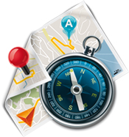
GPS Coordinates WGS84 Datum
US-89 & K2565
37°08.698 N
112°34.078 W
Turn onto K2605
37°08.710 N
112°33.885 W
First "Y" in road
37°09.522 N
112°33.597 W
Enter dry streambed
37°10.643 N
112°32.827 W
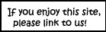
Red Canyon Slot
37°10.765 N
112°33.563 WGPS coordinates are only references and may or may not be accurate. - Do not rely on GPS coordinates as the sole method of navigation. Always have an accurate, detailed map at hand and have the proper map reading and navigation skills before setting out on any hike. Many of the hikes listed in this guide travel into canyons where a GPS has limited capabilities. Always check your position with a detailed map before dropping into a canyon.
Beta: Coordinates and other trail and canyoneering information by Zion Park search and rescue veteran team member Bo Beck and www.zionnational-park.com author, Tanya Milligan.
Suggested Gear: Rope, webbing, harness and rappelling device. A sturdy pair of shoes are recommend for canyoneering in Zion . Quality shoes will help grip the rocks and prevent injury. Experienced Zion hikers and canyoneers like the Sportiva Exum Ridge. This shoe is great for hiking, bouldering and canyoneering.

Share

Web Southwest Parks

Zion National Park, Utah

